**CURRICULUM VITAE**

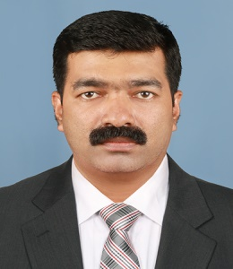**Jolly Thomas K T**

**Kurumpayil House**

**Vattiamthode P O**

**Kannur District**

**Kerala, India Pin 670705**

**Email: jollythomaskt@gmail.com**

**Contact No. 8281183095 8921264772**

**Career Objective**

**To motivate and help children to become responsible citizens**

**Qualifications**

|  |  |  |
| --- | --- | --- |
| **Course** | **University** | **Percentage of Marks** |
| **M.A. English** | **Osmania University Hyderabad** | **60** |
| **B.Ed. English** | **Mysore University** | **74** |

**Experience**

|  |  |  |
| --- | --- | --- |
| **Name of the Institute** | **Duration** | **Classes Taught** |
| **Gomathy E.M. School,**  **Nellore (CBSE)** | **2003-2005** | **4-6** |
| **Ryan International School,**  **Raebareli(ICSE)** | **2005-2008** | **5-10** |
| **The Laidlaw Memorial School and Junior College, Ketti (ICSE&ISC)** | **2008-2010** | **8-12** |
| **St. Michael’s Anglo Indian H.S.S., Kannur (Kerala State Board)** | **2011-2023** | **8-10** |

**Achievements**

**Attended workshops conducted by ICSE**

**Could help students to create records in ICSE , ISC & State Board Exams**

**NCC ANO since 2018**

**Personal Profile**

**Father’s Name : Thomas**

**Mother’s Name : Mary**

**Date of Birth : 17 April 1980**

**Permanent Address : Kurumpayil House**

**Vattiamthode P O**

**Kannur District**

**Kerala Pin 670705**

**India**

**Languages Known : English, Hindi, Malayalam**

**Nationality : Indian**

**Gender : Male**

**Marital Status : Married**

**Strengths : Confidence**

**Willingness to work tirelessly for a good cause**

**Declaration**

**I hereby declare that the details given above are true to the best of my knowledge.**

**Place: Kannur Sd/**

**Date : 22/04/2023 Jolly Thomas K T**